CPD module workbook

Talking to People

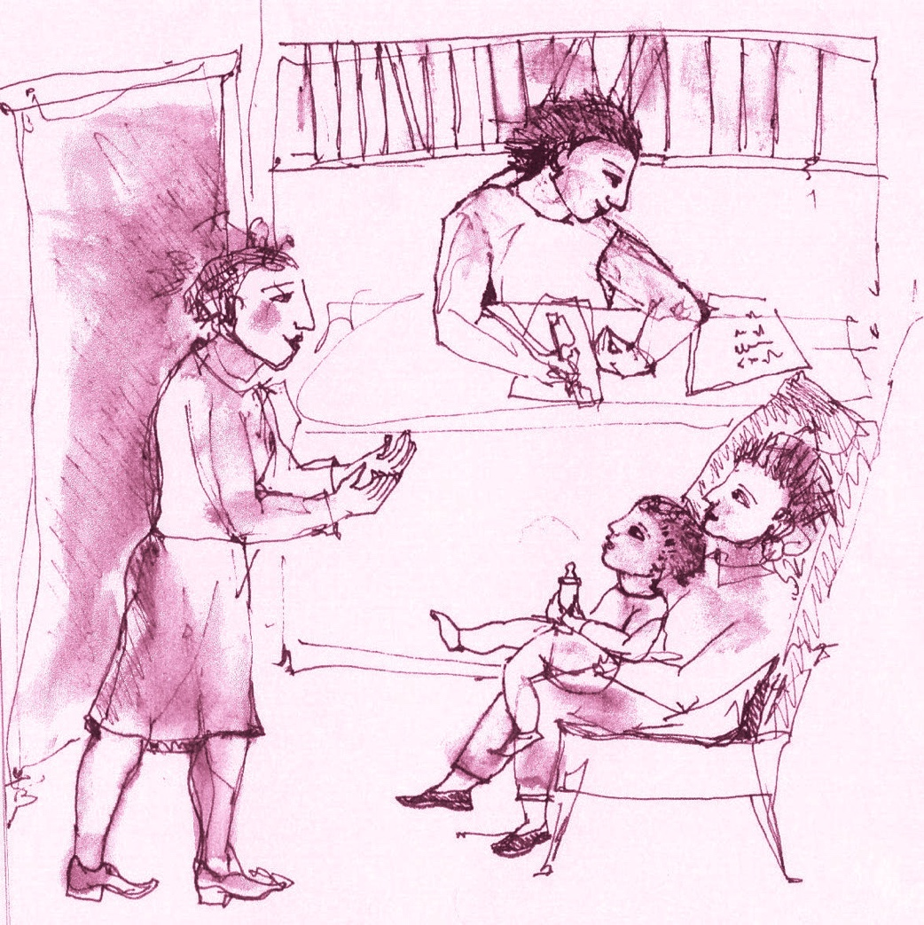

This module addresses the basic skills that have been found to be important in engaging people with addiction problems, maintaining that engagement and helping them move towards recovery and, therefore, improvements in health and social functioning.

This is why we are talking about talking to people.

This workbook has been designed for use in conjunction with
result4addiction. It will take you to the relevant content in the website. You can download the workbook from the website.

Contents

Read this guidance before you start 3
Key to icons 3
Topic One: the context for talking to people – a positive organisational culture 4
Task 1 - Help seeking… 4
Task 2 - From the Effective Places page… 5
Dealing with intoxicated behaviour 6
Task 3 - The Debating Box 7
Task 4 - Your Study Group 9
Topic Two: who are the most effective practitioners? 10
Task 1 - From the Effective People page… 10
Task 2 - The Debating Box 11
Task 3 - Your Study Group 13
Topic Three: it is all about using motivational dialogue 14
Task 1 - From the Drug and Alcohol Testing page… 14
Task 2 - The Debating Box 15
Task 4 - Your Study Group 17
Topic Four: why is it important to talk to family and friends? 18
Task 1 - From the Trusted People page… 18
Task 2 - The Debating Box 19
Task 3 - Your Study Group 21
Now try the Talking to People Quiz… 22

Read this guidance before you start

There are 4 topics in this module:
- The context for talking to people – a positive organisational culture.
- Who are the most effective practitioners?
- Is it all about using motivational dialogue?
- Why is it important to talk to family and friends?
You can work through the topics at your own pace, however, to keep up a momentum we suggest spending two weeks on each. Each topic has a variety of tasks (see icons below): watching videos, reading scientific articles, taking in checklists, for example.

Use the workbook to navigate the four topics. Be sure to add your reflections in the spaces provided. When you have completed the module, you can save the workbook as a digital record or download a hard copy of your work.

Ideally you will convene, or join, a Study Group (this could be a peer group, just one colleague, or a trusted supervisor) for your topic discussions. Arrange your meeting times right away and use these as the deadline for completion of each topic. The aim of the Study Group is to sharpen up your thoughts.

Key to icons

  - This is a task where you are asked to reflect on a question.

  - This task takes you to a page in the website and points to the essential reading.
  - The Debating Box flags up a controversial current issue and invites your reflections.
  - At the end of each topic you should meet with your study group and review what you have studied.

  - This is where you write down your thoughts and plans.
  - This indicates an open access article – one that is free to view and download.
  - This indicates an article where you must pay to view or access via your institution.

  - Please note that you should scroll through the document or click if you want to jump to the next place to enter your reflections.

Topic One: the context for talking to people – a positive organisational culture
1

It is said that first impressions count. This topic is about understanding the characteristics of an effective workplace, how the organisation of the service promotes or inhibits optimism for change.

Task 1 - Help seeking…

You are approaching a place that you are seeking help from…

- What would make you feel welcome?
- What would make you feel you had come to the right place?
- What would make you feel that people in this place were concerned about you?
- What would make you feel that the help you were seeking was going to be forthcoming?

Reflect on these questions and how you would ‘meet and greet’. Try out your plan and modify it until it feels comfortable and natural. Write down your ideas in the space below.

Please type your notes here.

Task 2 - From the Effective Places page…

- Watch the video of Professor Fanny Duckert who talks about ways of working that create a positive service ethos. Pay attention to her points about the uniqueness of the individual, being mindful of gender differences, conditions for group and individual treatment, the importance of the first session in giving immediate help and hope, telling people what to expect, setting some ground rules and making a commitment by discussing what you will do in subsequent sessions.
- Look down the checklist of what makes a good Team Player and see how well you match up.
- At the bottom of the page go to the Key Findings and read through the research articles on organisational effectiveness and note the things that service users want from a service.

Go to the Effective Places page in result4addiction

What do you think the most important aspects of organisational culture are? Write them in the space below.

Click or tap here to enter text.

…and one more thing…

Dealing with intoxicated behaviour

Intoxication and the resulting disruptive behaviour are a common occurrence in some settings, and so, agencies might think of having a policy and staff training programme for how to talk to people in these circumstances. Here is an extract from a textbook on the management of addiction Seminars in Addiction Psychiatry (Raistrick & Tober, 2021 pp128-146).

It is useful to distinguish between intoxication, which is the result of a particular blood alcohol level, and drunkenness, which refers to a range of behaviours that are somewhat independent of blood alcohol levels. Alcohol is a drug with a moderate degree of plasticity meaning that its effects can be shaped to some extent by drinkers’ beliefs and perceptions of their internal and external environment – witness national stereotypes of drinking and how these cultures lead to people behaving differently even though they are consuming equivalent amounts of alcohol.

It follows that for any drunkenness incident the impact of culture and the environment on behaviour can be modified. For example, where the environment and the people in it are perceived as hostile, then aggressive or defensive behaviour is likely to ensue. Calm and unthreatening behaviour by staff will minimise the risk to all present and facilitate de-escalation. There are some key points to follow: i) make sure that both staff and service user can see an easy escape route; ii) introduce yourself and call the service user by their name; iii) get the service user to sit down with you to avoid towering over them; iv) make facilitating rather than rejecting statements – for example instead of saying “you cannot be seen now” say “wait over here and I will see you in twenty minutes”; v) describe what the service user should do in order to take things forward. The senior practitioner present should be competent to take a lead in managing people exhibiting drunken and possibly aggressive behaviour. Training and a consistent team response are important for dealing effectively with these situations.

Task 3 - The Debating Box

The Motion: Treatment agencies are choking on national data reporting requirements at the expense of building rapport

For…
The demands for more and more data are a considerable burden on both practitioners and service users. It is unethical to collect information from service users that does not have a direct benefit for them. Agencies should be able to collect whatever data they find useful without hindering talking to people.

Against…
The provision of addiction services is mainly funded by government; it is important to monitor how public money is spent and whether agencies are delivering the outcomes expected. All of the data required are useful for agencies to help improve outcomes.

Of course, both sides of this debate have good points to make. Often service users are frustrated by the amount of information asked for which seems to them irrelevant to their problem. To help your thinking about where the right balance lies, consider, in your own practice: what information do you need to help your service users? What data do you collect that is likely to be unreliable? What data is helpful for planning service needs and delivery? Talk to people about how the information you wish to collect will be used.

This article looked at what agencies did with the data that they collected.

Wisdom JP, Ford JH, Hayes RA, Edmundson A, Hoffman K and McCarty D (2006) Addiction Treatment Agencies Use of Data: a Qualitative Assessment. The Journal of Behavioral Health Services and Research. 33, 394-407 DOI: 10.1007/s11414-006-9039-x

There is a summary of the key findings on the next page…

Summary

The researchers found that treatment agencies made data-driven decisions aiming to improve service user access to and retention in care. Factors associated with success and barriers to change are listed below.

The key to successful data driven service improvement
- Agency leaders value data collection and commit resources to data management.
- Staff training is provided to explain why data collection is important and what the data are to be used for.
- Sharing of changes is achieved by data driven plans at staff meetings, posts on noticeboards or emails.
- Locally available data are used to support audit projects and ensure feedback to all stakeholders.

Barriers to data driven service improvement
- When databases are not designed to follow the complexities of how local services work.
- Expertise and resources to manage and analyse data are not available at a local level.
- Staff believe that the data collection is not relevant and detracts from the business of delivering quality care.
- Staff are concerned that data will be used against them and that the uniqueness of their agency will not be captured.

Write down your thoughts on how data collection could be improved in your service. You can edit this section as often as you want.

Click or tap here to enter text.

Task 4 - Your Study Group

Once you are happy that you have covered all the tasks, it’s time to go to your study group discussion. Here are some suggestions for structuring your discussion…

- What changes could be made in your organisation to increase the message that people are welcome when they walk through the door?
- What implications are there for your service from the points made by Professor Duckert?
- What are your conclusions, having completed the checklist of what makes a good team player?
- Does your service deliver service user satisfaction? What happens if a service user’s wishes conflict with the practitioner’s views?

Record your thoughts below. You can edit this section as often as you want.

Click or tap here to enter text.

Topic Two: who are the most effective practitioners?
2

This topic is about why some practitioners are better than others at helping service users. For obvious reasons this is a subject that practitioners, but also supervisors, often avoid talking about.

Task 1 - From the Effective People page…

- Watch the video of Carl Rogers, a founder of the humanistic approach to counselling; be sure you understand the meaning of empathy and its impact.
- Watch the video of Professor Martha Sanchez-Craig; note what she says about effective counsellors, namely: that they are knowledgeable, flexible and skilful and that they offer immediate help. At the bottom of the webpage, go to Key Findings of the research and see the big differences in successful treatment which are accounted for by the practitioner’s style of working.

Go to the Effective People page in result4addiction

What do you think are the ‘must have’ characteristics of an effective practitioner? Is there anything you want to change about your own practice? You can edit this section as often as you want.

Click or tap here to enter text.

Task 2 - The Debating Box

The Motion: To be effective, supervision needs to be undertaken by practitioners with addiction expertise

For…
It is not only expertise in the treatment method which is important, but knowledge of the condition to which it is applied, as well as knowledge of the target population. Effective supervisors are accepted as having particular expertise and experience in the treatment of addiction problems.

Against…
Expertise in a particular treatment method enables the supervisor to address any behaviour problem in any context. There is an advantage in supervisors being remote and independent of agency and locality concerns, so as to remain unbiased in giving guidance.

It is generally agreed that supervision of practitioners at all levels is an important part of professional development and ensuring safe practice. How best to do it is not so clear. In your own practice think about i) Who gives you supervision? ii) Do you find supervision helpful in your daily practice? iii) Would a different kind of supervision be better for you?

This conference poster paper looks at two different ways of doing supervision.
Meier A, McGovern MP, Lambert-Harris C, McLeman B, Saunders EC (2016) A pilot trial of two models of clinical supervision of Integrated Cognitive Behavioral Therapy for co-occurring PTSD and substance use disorders. Poster presented at College on Problems of Drug Dependence conference, Palm Springs, California.

There is a summary of the key findings on the next page…

Summary

The research compared two models of supervision, a centralised model whereby an expert trains and directly supervises therapists by providing coaching and feedback, and a localised model whereby the supervisor is trained in the specific intervention, is committed to its implementation and champions its use within the agency…

- All therapists were rated above adequate on adherence to treatment protocol and competence (all were Masters degree level).
- Ratings of adherence and competence were similar in both supervision model groups.
- Most importantly where the therapists received localised supervision there was a greater reduction in days using drugs at three months follow-up.
Overall, the researchers found that the evidence leans towards localised supervision from a competent practitioner.
Write down your thoughts on what you see as the ideal supervision arrangement. Is there anything you want to change within your own practice? You can edit this section as often as you want.

Click or tap here to enter text.

Task 3 - Your Study Group

Once you are happy that you have covered all the tasks, it’s time to go to your study group discussion. Here are some suggestions for structuring your discussion…

- How has the concept of empathy evolved since Carl Rogers and why was his contribution important?
- What are the implications of Professor Sanchez-Craig’s research for recruitment, training and supervision?
- What are the takeaway messages from the research findings?
- Supervision of practitioners seems to be an important factor in client outcomes. Can supervision in your agency be improved?

Record your thoughts below. You can edit this section as often as you want.

Click or tap here to enter text.

Topic Three: it is all about using motivational dialogue
3

Getting any information from service users can come across as being intrusive and often repetitive. Filling out questionnaires or something physical such as drug testing are examples of this. This topic is about having a positive conversation with service users that avoids getting into arguments. Drug and alcohol testing is used as an example but the idea of interacting in a motivational way is applicable in all circumstances.

Task 1 - From the Drug and Alcohol Testing page…

- Take note of the Practitioner Preparation and Practitioner Skills boxes.
- Read the How to Do It dialogue and be sure you understand how this way of talking avoids confrontation, and reduces the likelihood of a negative outcome for your service user.

Go to the Drug and Alcohol Testing page in result4addiction

Write down the essentials of interacting in a motivational way. Are there ways that you will change your own practice?. You can edit this section as often as you want.

Click or tap here to enter text.

Task 2 - The Debating Box

The Motion: Creating rapport is more important than getting on with treatment
For…
You need to establish rapport before you can talk about the substance use and its treatment. If there is no rapport then there is no point to any kind of intervention; service users will not take in anything that is said to them, they will probably dislike their practitioner, and are likely to drop out.

Against…
Establishing rapport needs to be part of dealing with the problem the service user wants help with. It is no good wasting time just trying to strike up some rapport. Service users want to know that they are going to get the help that they need and that their practitioner has that as their focus.

The question here is whether building rapport is enough. Of course, it is important but so is getting on with some form of intervention. The point is illustrated in this short article by a young doctor in training, who talks about his experience during the COVID pandemic when, for a variety of reasons, it was proving difficult to establish rapport with people being admitted to hospital with a life-threatening illness.

Butt MF (2021) Clinical Medicine 21: e662–3
doi: 10.7861/clinmed.2021-0264

There is a summary of the key points on the next page…

Summary

In all the busy hospital departments during the COVID pandemic it was crucial to get on with essential treatments, but it was also important to establish rapport and try to put people who were experiencing distressing and potentially life-threatening symptoms at ease. It is important to experiment with what works for the practitioner’s style and what is acceptable to the huge mix of service users.

- The key challenge of rapport building is posed by the sheer diversity of service users.
- Building an effective rapport improves compliance with treatment, satisfaction, and overall outcome.
- In a busy department there is no time to 'talk about the weather' and so you have to establish rapport quickly as part of getting on with the care programme.
Write down your thoughts on how to get the balance between establishing a good rapport but also getting on with an intervention. You can edit this section as often as you want.

Click or tap here to enter text.

Task 4 - Your Study Group

Once you are happy that you have covered all the tasks, it’s time to go to your study group discussion. Here are some suggestions for structuring your discussion…

- What have you learned from the suggested approach to conversations about drug testing? In what other situations might this be useful?
- What particular skills did you notice in the reported dialogue?
- How confident do people in your study group feel about establishing rapport as part of getting on with business?

Write down your thoughts below. You can edit this section as often as you want.

Click or tap here to enter text.

Topic Four: why is it important to talk to family and friends?
4

It is always a good idea to encourage support from family and friends, indeed this is the basis of Social Behaviour and Network Therapy which is one of the most effective treatments for addiction.

Task 1 - From the Trusted People page…

- Read about being a Trusted Person. Not everybody is going to be a positive influence, so, be sure you understand who to encourage and who to discourage.
- Think about tips you can offer to family and friends on how best to help.
- Look at suggestions for excluding people who want to help but aren’t helpful.
- At the bottom of the webpage, go to Key Findings of the research and note how practitioners can coach Trusted People to be helpful in bringing about change.

Go to the Trusted People page in result4addiction

Write down why you see it as important to talk to family and friends. You can edit this section as often as you want.

Click or tap here to enter text.

Task 2 - The Debating Box

The Motion: Everybody should be encouraged to use social media as part of their support network

For…
It is self-evident that people with addiction problems are particularly likely to benefit from social media. Inevitably addiction leads to relationships breaking down and leaving people with no social support and especially so for those individuals who do not like mutual aid groups.

Against…
The world of social media is toxic and hard enough to navigate for people without an addiction problem. Being intoxicated would put an individual at risk of disclosing sensitive information or making badly judged posts on social media. Anyone with mental health problems would be vulnerable to abuse.

Many people with addiction problems have lost their real-world support, and their confidence in face-to-face interaction; therefore, it is tempting to suggest social media as an alternative form of social support. Read this study which highlights some of the risks involved.
Luchtefeld C and Jordan KD (2022) Individual Differences Influencing the Relationship between Online Social Support and Addictive Use of Social Media. Telematics and Informatics Reports 8 100025 doi.org/10.1016/j.teler.2022.100025

There is a summary of the key findings on the next page…

Summary

Social media as a social support can become an addiction. This study points to the importance of recruiting face-to-face sources of social support, of using social media as an adjunct for sources of social support and doing so with caution, looking out for social anxiety.

- People low in social anxiety and high in offline support have the lowest levels of social media addiction.
- People with high levels of social support online are more likely to experience addictive use of social media.
- People with high levels of social anxiety are more likely to experience social media addiction.
- The highest levels of social media addiction were observed in people with high levels of online social support, low levels of offline social support and high levels of anxiety.

Write down your thoughts on the use of social media to help people with addiction problems. What are you planning to do to ensure safe use? You can edit this section as often as you want.

Click or tap here to enter text.

Task 3 - Your Study Group

Once you are happy that you have covered all the tasks, it’s time to go to your study group discussion. Here are some suggestions for structuring your discussion…

- What would a trusted person look like if you were planning a big change in your life? Practising this on yourself can help you to assist another.
- What are your thoughts on how you get people who are giving support to communicate with each other?
- How do you see the role of social media as a means of support?

Record your thoughts below. You can edit this section as often as you want.

Click or tap here to enter text.

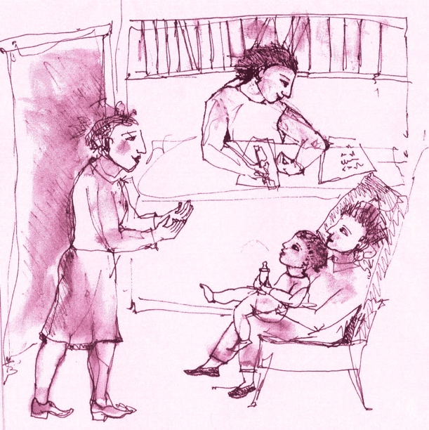

Now try the Talking to People Quiz…

The quiz is there solely for your use to see how much you have absorbed from the Talking to People module – it is not a test or exam. You may find it useful to highlight things you want to go over again.

Go to the CPD Modules page in result4addiction to launch the quiz.

